Reinforcement

Positive Reinforcement
The presentation of something immediately following a response/behaviour, which increases the likelihood that the response/behaviour will occur again in the future (Alberto & Troutman, 2003).
E.g. Giving a child a gummy worm because she put on her coat independently.

Reinforcer
Something presented after a response/behaviour, which increases the likelihood the response/behaviour will occur again in the future (Alberto & Troutman, 2003).
E.g. The gummy worm is the reinforcer when the child gets dressed independently.

Why is Reinforcement Important?
Reinforcement can be used to teach new skills, teach a replacement behavior for an interfering behavior, increase appropriate behaviors, or increase on-task behavior (AFIRM Team, 2015). It can also strengthen the duration (length), magnitude (intensity), and/or topography of a behaviour (what the behaviour looks like) (Cooper, Heron, & Heward, 2007).
E.g. Your child can successfully sit in a chair for one minute before they leave the table at dinnertime. You want to increase the duration (or length) of time the child can sit in the chair. Reinforcement is a tool that can help to increase this duration.

Types of Reinforcers
(Cooper, Heron, & Heward, 2007)
Edible Reinforcers | Preferred foods/drinks
Sensory Reinforcers | Preferred sensory stimulation such as tickles, massager, music, sparkling lights etc.
Tangible Reinforcers | Preferred toys, stickers, etc.
Activity Reinforcers | Preferred games, leisure activities, listening to music, privileges (1st in line), special events (trips to the movies)
Social Reinforcers | Physical Contact, praise, attention

How to Incorporate Reinforcement At Home
Praise
- Giving praise to your child (E.g. “Good job!”, “Great work!”) when they complete a task you have ask them to do and/or they are behaving appropriately
Material Rewards
- Giving out stickers
- Giving out treats: If you eat all your dinner, you can have a cookie
- Giving out preferred toys: If you walk to the car nicely, you can have your iPad in the car
- Giving out preferred activities: If you do your homework everyday this week, we can go to the movies on Friday
Free Time/Play Time
- Giving the child free time when a task is done: You need to get dressed for school, and then you can have five minutes to play

How to Make Reinforcement Effective (Cooper, Heron, & Heward, 2007)
When you see the behaviour you want to increase (E.g. compliance, sitting quietly, etc):
- Ensure reinforcement is immediate
- Ensure you are using highly preferred items as reinforcement
- Ensure you are reinforcing (or giving reinforcement) after every occurrence of positive behaviour at first (i.e. every positive behaviour earns the child reinforcement)

When Not to Reinforce
When your child is exhibiting a behaviour you want to see decrease
(E.g. non-compliance, aggression, etc.)

Token Economies
What is it? | Why Is It Important?
It is a delivery of a symbolic or token reinforcer (E.g, poker chips, points, checkmark) following the correct performance of specific behaviour(s) (Miltenberger, 2001). You can start with requiring the child to earn one token before they access their reinforcer. You can then gradually build this to multiple tokens, as illustrated below. | They are important because they allow the child to see something concrete that they are working for, and how far away that item is (i.e. I only need three more check marks until I can play with playdough).  Tip  Make sure to always allow the child to choose what they are working for. This will increase compliance with the task.
Examples of Token Economies
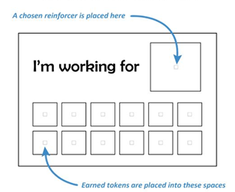
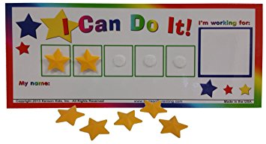

First-Then Board
What is it? | Why Is It Important?
A “First-Then” board is a visual tool that shows the child the activity you want them to complete, and the reinforcing activity that will follow.  The “First” is usually a non-preferred or neutral activity, and the “Then” is always a preferred toy/activity that will serve as reinforcement for completing the harder task.  The pictures can be attached using Velcro so they can be changed when necessary.  A First/Then board is portable and move with the child as he/she transitions (Hume, 2008). | First-Then boards provide:  - Predictability  - Reward completion of an undesired task  - Break down a larger schedule  (Visual Strategy Kit, Thames Valley Children’s Centre)  First-Then boards are useful for children with non-compliance when completing a non-preferred activity or task.  They are also useful for children who have trouble transitioning from activity to activity or room-to-room. First-Then boards help the child transition to an activity or location that is not preferred, because the child can visually see that a preferred activity is coming next.
Examples of First-Then Boards
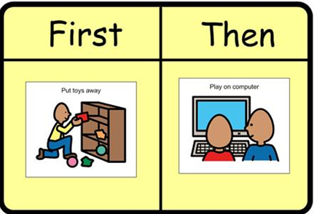
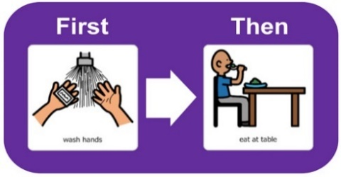

References
AFIRM Team (2015). Reinforcement. Chapel Hill, NC: National Professional Development Center on Autism Spectrum Disorder, FPG Child Development Center, University of North Carolina. Retrieved from http://afirm.fpg.unc.edu/Reinforcement
Alberto, P. & Troutman, A. (2003). Applied behaviour analysis for teachers (6th ed.). New Jersey: Merrill Prentice Hall.
Cooper, J. O., Heron, T. E., & Heward, W. L. (2007). Applied behavior analysis (2nd ed.). Upper Saddle River, NJ: Pearson Education, Inc.
Hume, K. (2008). Transition time: Helping individuals on the autism spectrum move successfully from one activity to another. The Reporter, 13(2), 6-10.
Larriba-Quest, K. (2017). Reinforcement in the classroom. The Reporter, 21(18). Retrieved from https://www.iidc.indiana.edu/pages/reinforcement-in-the-classroom

Miltenberger, R. G. (2001). Behavior modification: Principles and procedures (2nd ed.). Belmont, CA: Wadsworth.

Visual Strategy Kit. School Support Program, Autism Spectrum Disorder. Thames Valley
Children’s Centre- Visual Strategies, Working for Boards, First-Then

