Visual Supports

What Are They?
Visual supports are pictures or words used to assist with understanding activities or instructions. Verbal instructions can be fleeting and vary quickly. Visuals are helpful as they allow your child to refer to them as often as needed when following their daily routine.
Why Use Visuals?
(Visual Strategy Kit)
- Provides instructions in a more concrete manner
- Breaks down a task into smaller components
- Decreases reliance on verbal prompting

Visual Strategies

Choice Board
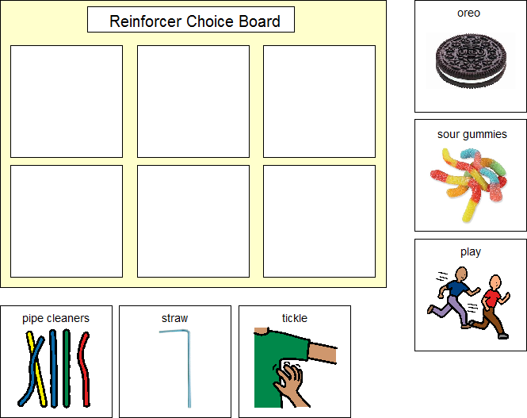
Free App
ChoiceBoard
Creator
Why Is it Useful?
Choice boards are pictures of a variety of preferred foods, toys, or games that your child is interested in. It allows the child to see what is available in each environment/at any given time.

Children may have a preference, but may have difficulty expressing it. Having a visual showing the varying available options can assist your child in choosing an item/activity. The child express this choice by pointing or by removing the picture and giving it to the parent.
Choice boards are also beneficial because they can change to accommodate what is available in specific environments. School may have some items, while at home there will be different items available.

Visual Schedules
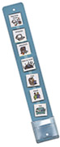
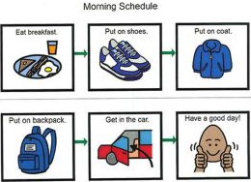
(i)
(iii)
Why Is it Useful?
Visual schedules can be used for one child, or multiple children in a group setting. There are visual schedules for: Dressing, Daily Routine, School activities, etc.
Typically they are on a strip of Bristol board with Velcro and the pictures can be removed when the activities are completed. Once completed, the child puts the picture in an “all done” envelope at the bottom of the schedule.
These schedules allow the child to see what is coming up next, and the child can also be involved with completing an activity or transition by putting the pictures in the “all done” envelope.
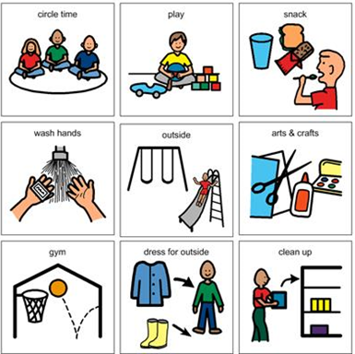
(ii)
Free Android Apps
-PictogramAgenda
-Visual
Schedule

First-Then Board
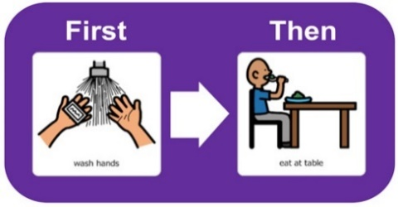
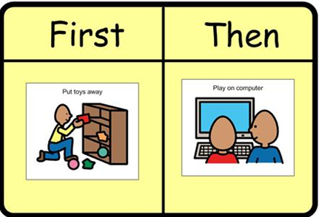
Free Android App
“First-Then”
The “First” in usually a
non-preferred activity.
The “Then” is a
preferred activity/toy that the child enjoys.
(iv)
(v)
Why Is it Useful?
A “First/Then” board can be a useful strategy so your child can see what activity they are completing currently and what activity will occur next (Hume, 2008).
The pictures can be attached using Velcro so they can be changed when necessary.
First-Then boards are useful because they:
Provide predictability
Reward completion of an undesired task
Breaks down a larger schedule
(Visual Strategy Kit, Thames Valley Children’s Centre)

First-Then boards are useful for children with non-compliance when completing a non-preferred activity or task.
They are also useful for children who have trouble transitioning from activity to activity or room-to-room. First-Then boards help the child transition to an activity or location that is not preferred, because the child can visually see that a preferred activity is coming next.
A First/Then board is portable and move with the child as he/she transitions
(Hume, 2008).

Token Board
(Visual Strategy Kit, Thames Valley Children’s Centre)
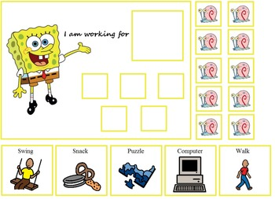
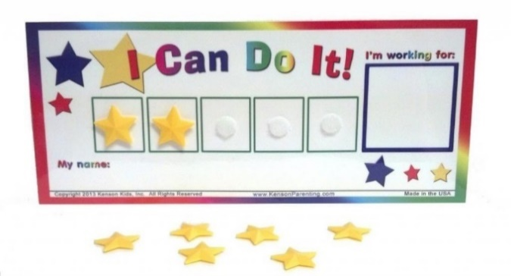
(vi)
(vii)
Why Is it Useful?
Token boards are visuals that specify the number of tasks a child must complete in order to gain a reward- an activity or toy that is highly motivating.
Each time a task is completed, a token is placed on the board. When the child has finished the specified number of tasks, they receive the reward.

The tokens can be stars, checkmarks, or pictures customized to the child’s interests (E.g. pictures of Dora)
Token Boards:
- Teach the child to wait longer before they receive a reward
- Increase motivation to complete undesired tasks
- Represents the amount expected from the child visually

Free Android Apps
-My Token Board
-EasyKidTokens

Social Stories/Narratives
(Hodgdon, 1995)
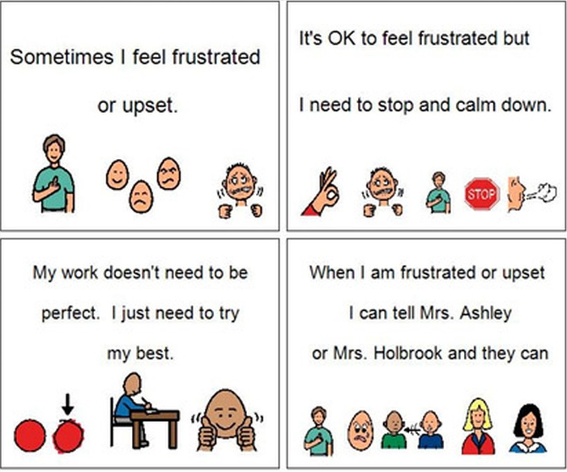
(viii)
Why Is it Useful?
Social stories are an individualized short stories that are used to model an appropriate social interaction, behavior or skill by describing a relevant social context to the child who is struggling.
Social Stories:
- Break down the challenging social situation by providing the child with other people’s perspectives and an appropriate response to the situation
- The goal of the story is to improve the child’s understanding of the social situation, which may lead to a change in behavior and appropriate decision making in future events similar to the story.
Social Stories Can Help Prepare
Children For:

- School field trips
- Grocery shopping
- Getting a hair cut
- Going to the doctor
- Going on an airplane
- Moving

Free Apps
-Social Story
Creator
-Library (Touch
Autism)

References
Hodgdon, L. Q. (1995). Solving social behavioral problems through the use of visually supported communication. In K. A. Quill (Ed.), Teaching children with autism: Strategies to enhance communication and socialization (p. 265-286). New York: Delmar.

Hume, K. (2008). Transition time: Helping individuals on the autism spectrum move successfully from one activity to another. The Reporter, 13(2), 6-10.
Visual Strategy Kit. School Support Program, Autism Spectrum Disorder. Thames Valley
Children’s Centre- Visual Strategies, Working for Boards, First-Then
(i) Retrieved from: http://www.leapsandboundskids.com/visual-supports-in-every-day-life (2018)
(ii) Retrieved from: https://boardmakeronline.com/Activity/11207726 (2018)
(iii) Retrieved from: http://www.oneplaceforspecialneeds.com/main/library_control_tantrums.html (2018)
(iv) Retrieved from: https://iris.peabody.vanderbilt.edu/module/asd1/cresource/q2/p06/first-then-picture-boards/ (2018)
(v) Retrieved from: https://www.boardmakeronline.com/Activity/282471 (2018)
(vi) Retrieved from: https://www.teacherspayteachers.com/Product/Autism-Spongebob-and- Patrick-Token-Boards-1669133 (2018)
(vii) Retrieved from: https://www.amazon.com/Kenson-Kids-Colorful-Positive-Reinforcement- Customizable/dp/B0034C1P32 (2018)
(viii) Retrieved from: https://fasdtoolkit.weebly.com/social-stories.html (2018)

