Transitions

What is a Transition?
When your child moves from one activity to another, or from one location to another.

Why are Transition Supports Important?
They are important to help prepare your child for upcoming events, which may alleviate challenging behaviour associated with this transition. Some children can anticipate events when you verbally tell them (E.g. “In five minutes, it’s time to go home”), however some children need extra visual support so this schedule is clear.

Small Transitions
Type of Transition | Examples
Activity-to-Activity Transitions | These are small transitions typically within one area, such as playing in the bedroom to getting dressed in the bedroom.
Room-to-Room Transitions | These are medium transitions typically moving from one space/room to another such as: moving from the child’s bedroom to the bathroom in the morning, or moving from the backyard back inside.
Big Transitions
Type of Transition | Examples
Changing Schools | Changing schools within the same city or moving to another city.
Moving | Moving to another house within the same city or moving to another city.
Adding a New Family Member | This is when a new spouse, sibling, or new pet is being added to the family. There will be many new changes with a new addition, which can be a big transition for your child.
Strategies for Small Transitions
Strategy | Example & Picture
Transitional  Warnings | Transitional warnings are meant for your child to have time to prepare, well in advance, before a transition- and up until that transition. For example you might give warnings at:  - 10 minutes  - 5 minutes  - 1 minute  You can say these warnings verbally or pair it with a visual. Some children may have difficulty understanding the concept of time, therefore multiple warnings and the use of a visual are helpful when preparing for a transition.
First-Then  Board | (i)  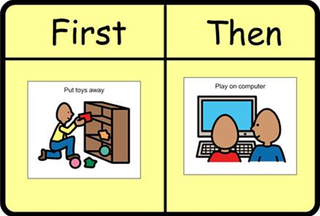  A "First/Then” board may be useful—as your child can see what activity they are currently completing and what activity will occur next. The activity that is happening “First” is usually a non-preferred activity (something the child might not want to do). The “Then” is always a preferred activity/toy (something the child wants/likes). This visual strategy may help your child transition to a location that is not preferred, if he/she is able to see that a preferred activity is coming next. A “First/Then” should be portable and move with your child as he/she transitions (Hume, 2008).  “First clean up your toys, Then computer”  “First go to therapy room, Then cookie”  Examples
Visual Timers | (ii) 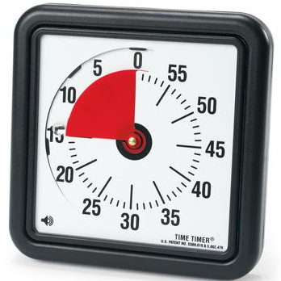 (iii) 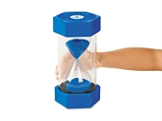  It may be helpful for your child to “see” how much time remains in an activity before they will be expected to transition to a new location or event. Concepts related to time are fairly abstract (i.e. “You have a few minutes”) and often cannot be interpreted literally (i.e. “Just a second” or “We need to go in a minute”). This may be confusing for your child, so using the visual timer is a strategy to support him/her through the transition (Hume, 2008).  Example  “Take a look, we have 10 more minutes to play outside, then we are going inside” – “When the red (or sand) is all done, it’s time to go”.
Activity Schedules | (iv)  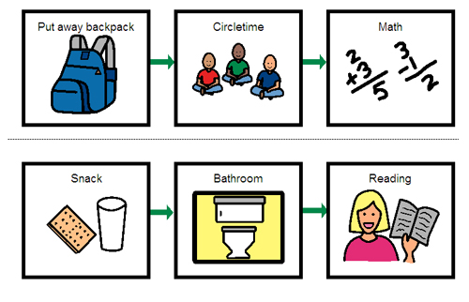  Some children may be able to understand when you verbally tell them what their day will look like (E.g. “We are going to go to KidsAbility, then home for lunch, and then you are going to grandma’s house”). However, some children need extra visual support to help them understand all the steps within their day.  Activity schedules are helpful for children to refer to throughout their day so they are able to predict what activity is coming next. Some schedules may be simpler and only have three pictures (activities) at a time, while others may have more pictures to show the activities of your child’s entire day.  Activity schedules can increase your child’s independence, as they are able to refer to it as often as needed.  Example  “First you will go to school, then you will ride the bus home. Next we will have dinner, then you go to your dad’s house”.  As you make each activity-to-activity or place-to-place transition, review the activities, which will assist with repetition and familiarity with the schedule.
Transitional Toy | There are 2 types of transitional toys/items:  - Item Representing Next Activity  Bringing an item your child transitions with (holds) that represents the location or activity they are going to next. If your child is a concrete learner, handing him an object that represents the area that he will be transitioning to may be most meaningful (Hume, 2008).  Example  A ball might represent going outside, and a lunch bag might represent the lunch table. You could also use pictures of these items to represent the next location/activity.  - Non-related Preferred Item  Bringing an item that is highly motivating and well-liked by your child.  Example  This could be an item your child is currently engaged with before making the transition, or an item that you know your child really enjoys such as an iPad, musical toy, and or playdough.  *Please note, you give this item to your child before you transition, you do not give it to your child after they have engaged in problem behaviour during a transition*

Strategies for Big Transitions
Strategy | Example & Picture
Social Stories | (v)  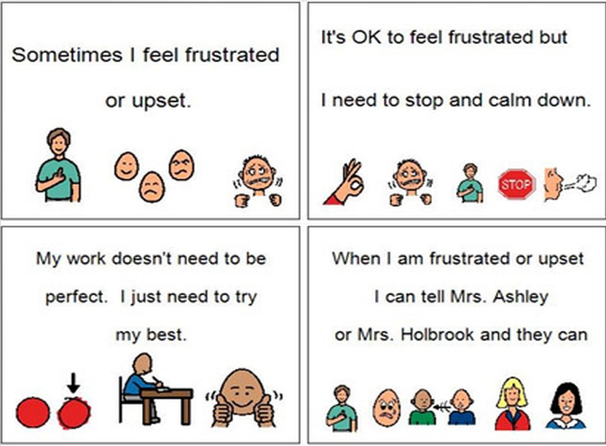  Social Stories are an individualized short stories that are used to model an appropriate social interaction, behavior or skill by describing a relevant social context to the child who is struggling with it. The story breaks down the challenging social situation by providing the child with other people’s perspectives and an appropriate response to the situation. The goal of the story is to improve the child’s understanding of the social situation which may lead to a change in behavior and decision making in future events similar to the story (Benish & Bramlett, 2011).  Examples  Different social story themes may be:  - When I go to the hair dresser  - Going on a field trip  - When I go to the movies  - Going to school  - Going on an airplane
Countdown Visual | 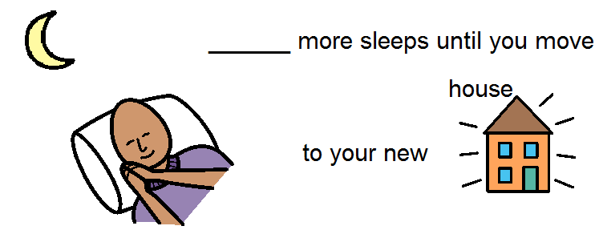  When your child is moving to a different city (or school), another strategy you can use is a countdown visual that outlines how many more days left until that move/change.  (vi)  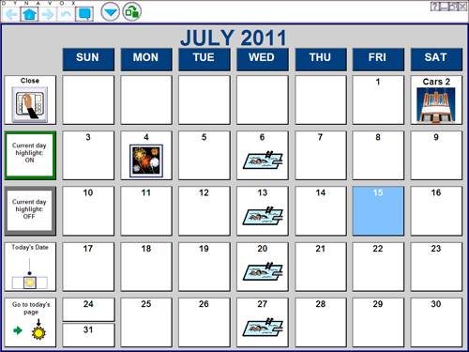  Using a visual calendar (monthly and/or weekly) will help your child predict when a big change is coming. Reviewing the calendar and the “how many sleeps” card with your child in multiple environments will help with repetition and familiarity of the visual supports.

References
Benish, T.M., & Bramlett, R.K. (2011). Using social stories to decrease aggression and increase positive peer interactions in normally developing pre-school children. Educational Psychology in Practice, 27(1), 1-17.
Hume, K. (2008). Transition time: Helping individuals on the autism spectrum move successfully from one activity to another. The Reporter 13(2), 6-10.
(i) Retrieved from: https://www.boardmakeronline.com/Activity/282471 (2018)
(ii) Retrieved from: http://www.discountschoolsupply.com/Product/ProductDetail.aspx?Product=27993 (2018)

(iii) Retrieved from: https://products.lakeshorelearning.com/learning/Visual-Timer (2018)
(iv) Retrieved from: http://www.autism-community.com/education/assistive-technology/
(2018)
(v) Retrieved from: https://fasdtoolkit.weebly.com/social-stories.html (2018)
(vi) Retrieved from: http://www.autism-community.com/visual-supports-tools-for-organization/ (2018)

