Antecedent Strategies

Antecedent: an environmental event that occurs before a specific behaviour
(Cooper, Heron, & Heward, 2007).

Why Are Antecedent Strategies Important?
Antecedent strategies have effectively been used to prevent problem behaviour from occurring.
ABC’s
Types of Antecedent Strategies
Environmental Manipulations
Adjusting or changing variables in your child’s environment can help to prevent challenging behaviour.
E.g. If you know that loud noises often cause your child to engage in problem behaviour ensure that you provide a quiet space for the child in your home, and provide headphones the child can wear in potentially noisy environments.
E.g. If your child reliably aggresses towards another child when they get too close, ensure that they are never in a situation where they are alone together, ensure you are positioned in between these children at all times.
E.g. Your child keeps getting into the cupboards at home, and takes out all of the pots and pans. As a preventative measure, you can install locks on these cabinets so the child does not have the opportunity to engage in this behaviour.

Offering Choice
You can provide choice to your child in so many different ways at home.
Some examples include:
- Choice in clothing (“Do you want to wear your pink sweater or your blue one?”)
- Choice in activity (“Do you want to read the princess book or letter book?”)
- Choice in order of activities (“Do you want to get a bath or brush your teeth first?”)
- Choice in food (“Do you want a cracker or grapes?”)

Your child can express choice verbally, through
picture exchange, sign language, gesture or eye
gaze, depending on the level of understanding
for your child.

Increasing Reinforcement
Children may engage in problem behaviour to receive attention from others, escape a task, access an item (E.g. toy/activity), or because the behaviour is internally reinforcing (sensory). To learn more about this, see the “Functions of Behaviour” handout.
When you know why your child is engaging in a particular behaviour, or what your child is trying to gain by engaging in this behaviour, you can provide that item/activity to the child freely to prevent or reduce the need to engage in the problem behaviour
(Cooper, Heron, & Heward, 2007).

Ways to Increase Reinforcement
Praise/Attention | Offering a Transition Toy
If your child enjoys receiving praise/attention from you or his/her siblings, provide lots of praise for appropriate behaviours as a preventative measure. Your child will learn he/she does not need to engage in problem behaviour to gain attention from others, he/she is already freely getting the praise and attention they crave! | This is a strategy for children who do not like to transition from room-to-room or place to place. You can offer your child a “transition toy” or a toy they can play with during that transition (E.g. from play time to bath time, from home to school). The child can play with the toy while walking to prevent problem behaviour.  *Please Note*  This is different from getting the toy as a  way to bribe/motivate them to transition after they have engaged in problem behaviour!

Functional Communication
You can teach your child to appropriately communicate (verbally, through picture communication, sign language or gesture) what they want to compete with problem behaviours (Cooper, Heron, & Heward, 2007).
- Teaching your child how to ask for a break (“Break”, gives parent a card that says Break)
- Teaching your child to ask for attention (“Look!”/”Excuse me”, tap on leg, etc)
- Teaching your child to ask for a toy/activity (“I want the iPad”, gives parent picture of iPad)
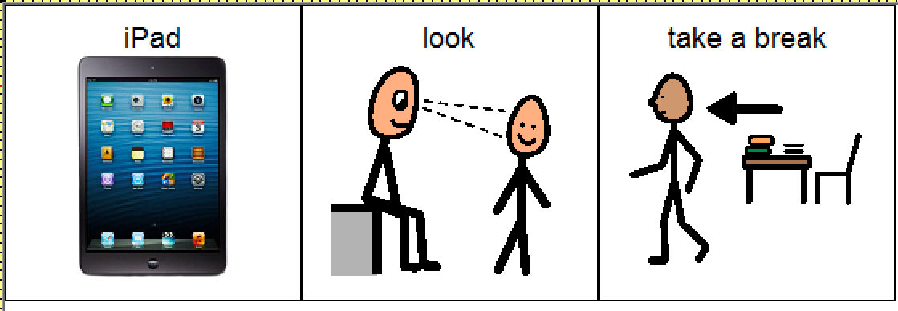

References
Cooper, J. O., Heron, T. E., & Heward, W. L. (2007). Applied behavior analysis (2nd ed.). Upper Saddle River, NJ: Pearson Education, Inc.
Reutebuch, C. K., Zein, F. E., & Roberts, G. J. (2015). A systematic review of the effects of choice on academic outcomes for students with autism spectrum disorder. Research in Autism Spectrum Disorders, 20, 1-16.

